Debouncing real life example:

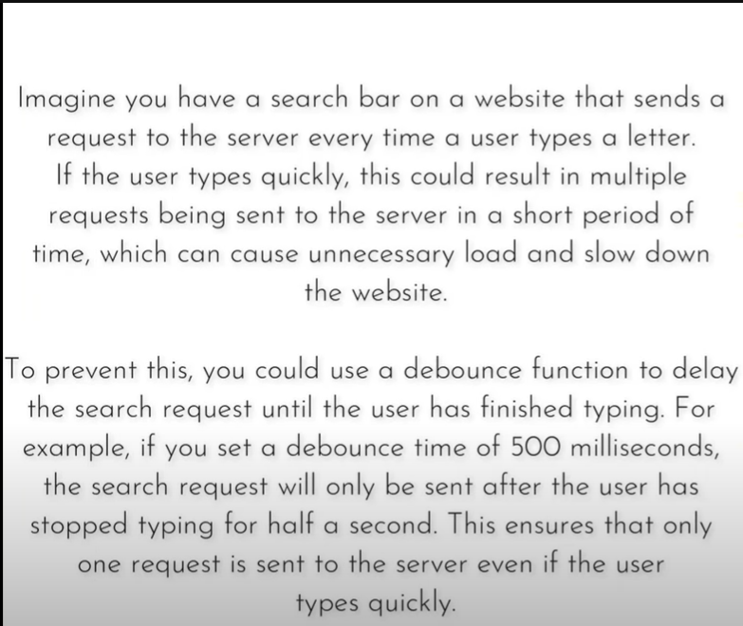

Throttling live examples:

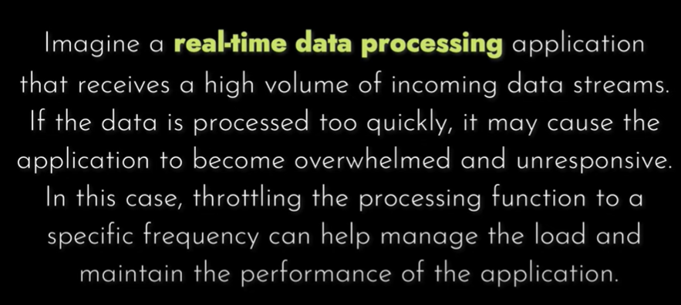

We don’t want chunks of data simultaneously but instead of this we want data on a particular frequency then we will use throttling bcz debouncing will give a lot of data at the same time which can makes our website performance low

Website to read about throttling vs debouncing :

https://www.thapatechnical.com/2023/02/throttling-vs-debouncing-in-javascript.html